
Specification Sheet

C.S.B. INTERNATIONAL PRODUCTS INC.

1 ½" x 1 ¼" Semi-Cast P-Trap w/Cleanout

Part Number | Size | Finish | Material
100CP | 1 ½" x 1 ¼" | Chrome Plated | Brass
100PC | 1 ½" x 1 ¼" | Polished Chrome | Brass

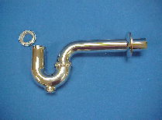

Tel: (860) 263-3635, Fax: (860) 229-4328

E-mail: sales@csbint.biz

41 Hammer Hill Road,
Rocky Hill, CT 06067

