
Specification Sheet

C.S.B. INTERNATIONAL PRODUCTS INC.

1 ¼" J-Bend Less Cleanout

Part Number | Size | Finish | Material
10100-1CP | 1 ¼" 22GA. | Chrome Plated | Brass
10100CP | 1 ¼" 20GA. | Chrome Plated | Brass
10110CP | 1 ¼" 17GA. | Chrome Plated | Brass

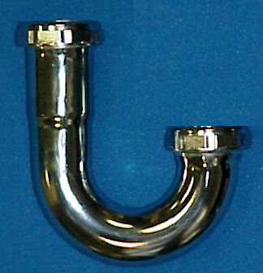

Tel: (860) 263-3635, Fax: (860) 229-4328

E-mail: sales@csbint.biz

41 Hammer Hill Road,
Rocky Hill, CT 06067

