
Specification Sheet

C.S.B. INTERNATIONAL PRODUCTS INC.

1 ½" Sink Trap J- Bends- Washer Joint

Part Number | Size | Finish | Material
10227-1CP | 1 ½" 22GA | Chrome Plated | Brass
10227CP | 1 ½" 20GA | Chrome Plated | Brass
10228CP | 1 ½" 17GA | Chrome Plated | Brass
10227-1RB | 1 ½" 22GA | Rough Brass | Brass
10227RB | 1 ½" 20GA | Rough Brass | Brass
10228RB | 1 ½" 17GA | Rough Brass | Brass

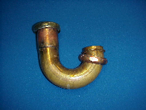

Tel: (860) 263-3635, Fax: (860) 229-4328

E-mail: sales@csbint.biz

41 Hammer Hill Road,
Rocky Hill, CT 06067

