
Specification Sheet

C.S.B. INTERNATIONAL PRODUCTS INC.

1 ½" P-Trap Less Cleanout With Ground Joint Connection
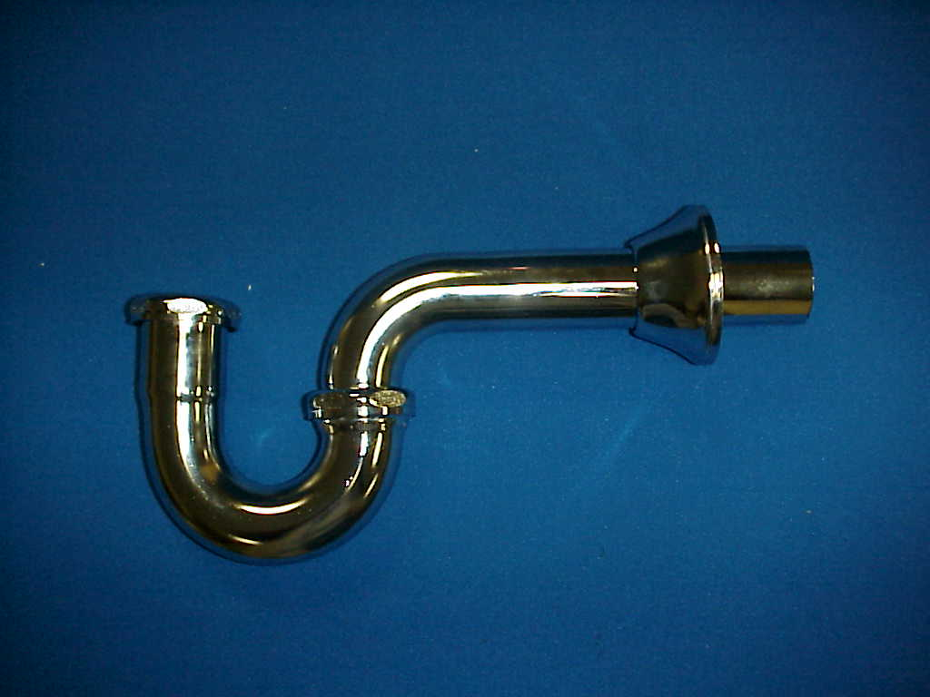
Part Number | Size | Finish | Material
115CP | 1 ½" 17GA. | Chrome Plated | Brass
115RB | 1 ½" 17GA. | Rough Brass | Brass
*Note: 1. For Deep Flange add "D" to catalog number.
2. For Brass Nuts add "B" to catalog number

Tel: (860) 263-3635, Fax: (860) 229-4328

E-mail: sales@csbint.biz

41 Hammer Hill Road,
Rocky Hill, CT 06067

