
Specification Sheet

C.S.B. INTERNATIONAL PRODUCTS INC
1 ½" Sink Trap Ground Joint

Part Number | Size | Finish | Material
1227CP | 1 ½" 20GA | Chrome Plated | Brass
1227PC | 1 ½" 20GA | Polished Chrome | Brass
1227RB | 1 ½" 20GA | Rough Brass | Brass
1228CP | 1 ½" 17GA | Chrome Plated | Brass
1228PC | 1 ½" 17GA | Polished Chrome | Brass
1228RB | 1 ½" 17GA | Rough Brass | Brass

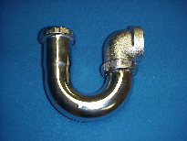

Tel: (860) 263-3635, Fax: (860) 229-4328

E-mail: sales@csbint.biz

41 Hammer Hill Road,
Rocky Hill, CT 06067

