
Specification Sheet

C.S.B. INTERNATIONAL PRODUCTS INC
Sink Trap Ground Joint w/Adapter & Brass Cover Tube

Part Number | Size |  | Adapter |  | Material / Nuts
1228BPC/PVC |  | 1 ½ " 17GA | PVC | Polished Chrome/ Brass
1228BPC/ABS |  | 1 ½ " 17GA | ABS | Polished Chrome / Brass
1228BPB/PVC |  | 1 ½ " 17GA | PVC | Polished Brass/ Brass
1228BPB/ABS |  | 1 ½ " 17GA | ABS | Polished Brass/ Brass
1228BPVD/PVC |  | 1 ½ " 17GA | PVC | Phys. Vap. Depos./ Brass
1228BPVD/ABS |  | 1 ½ " 17GA | ABS | Phys. Vap. Depos./ Brass

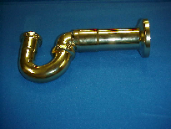

Tel: (860) 263-3635, Fax: (860) 229-4328

E-mail: sales@csbint.biz

41 Hammer Hill Road,
Rocky Hill, CT 06067

