
Specification Sheet

C.S.B. INTERNATIONAL PRODUCTS INC.

1 ½" Sink Trap Ground Joint adapter & Brass Cover Tube w/Cleanout

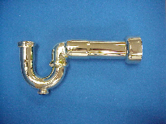
Part Number | Size |  | Adapter |  | Finish / Material
1234BPC/PVC |  | 1 ½ " 17GA | PVC | Polished Chrome/ Brass
1234BPC/ABS |  | 1 ½ " 17GA | ABS | Polished Chrome / Brass
1234BPB/PVC |  | 1 ½ " 17GA | PVC | Polished Brass/ Brass
1234BPB/ABS |  | 1 ½ " 17GA | ABS | Polished Brass/ Brass
1234BPVD/PVC |  | 1 ½ " 17GA | PVC | Phys. Vap. Depos./ Brass
1234BPVD/ABS |  | 1 ½ " 17GA | ABS | Phys. Vap. Depos./ Brass

Tel: (860) 263-3635, Fax: (860) 229-4328

E-mail: sales@csbint.biz

41 Hammer Hill Road,
Rocky Hill, CT 06067

