
Specification Sheet

C.S.B. INTERNATIONAL PRODUCTS INC.

1 ½" La Code Traps Ground Joint-Cast Elbow-Brass Nuts

Part Number | Size | Finish | Material
1242BCP | 1 ½" 17GA | Chrome Plated | Brass
1242BRB | 1 ½" 17GA | Rough Brass | Brass

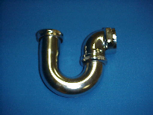

Tel: (860) 263-3635, Fax: (860) 229-4328

E-mail: sales@csbint.biz

41 Hammer Hill Road,
Rocky Hill, CT 06067

