
Specification Sheet

C.S.B. INTERNATIONAL PRODUCTS INC.

1 ¼" O.D. Corrosion Resistant - Heavy Duty 18 Gauge Tubing
14 Gauge Flanges

Part Number | Size A | Finish | Material
12512CSG | 12" | Bright Satin - Peened | Stainless Steel
12516CSG | 16" | Bright Satin - Peened | Stainless Steel
12518CSG | 18" | Bright Satin - Peened | Stainless Steel
12524CSG | 24" | Bright Satin - Peened | Stainless Steel
12530CSG | 30" | Bright Satin - Peened | Stainless Steel
12532CSG | 32" | Bright Satin - Peened | Stainless Steel
12536CSG | 36" | Bright Satin - Peened | Stainless Steel
12542CSG | 42" | Bright Satin - Peened | Stainless Steel
12548CSG | 48" | Bright Satin - Peened | Stainless Steel

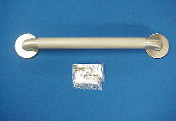

Tel: (860) 263-3635, Fax: (860) 229-4328

E-mail: sales@csbint.biz

41 Hammer Hill Road,
Rocky Hill, CT 06067

