
Specification Sheet

C.S.B. INTERNATIONAL PRODUCTS INC.

1 ¼" P-Trap, W/ CO., Polished Chrome*

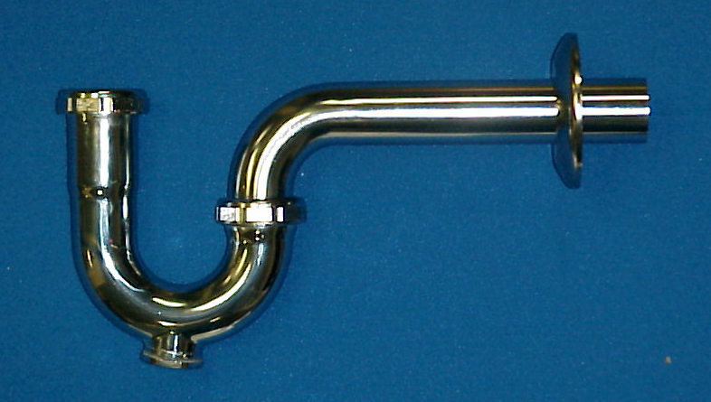
Part Number | Size | Finish | Material
12PC | 1 ¼" 20 GA. | PC | Brass, Zinc Nuts
13PC | 1 ¼" 17 GA. | PC | Brass, Zinc Nuts
*Note: 1. For Deep Flange add "D" to catalog number.
2. For Brass Nuts add "B" to catalog number.

Tel: (860) 263-3635, Fax: (860) 229-4328

E-mail: sales@csbint.biz

41 Hammer Hill Road,
Rocky Hill, CT 06067

