
Specification Sheet

C.S.B. INTERNATIONAL PRODUCTS INC.

1 ½" O.D. Corrosion Resistant – Heavy Duty 18 Gauge
14 Gauge Flanges
Conforms to ADA, ASTM & ANSI Requirements

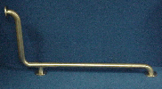
Part Number | Size | Finish | Material
1501632TSC | 16" x 32" | Bright Satin | Stainless Steel
1502424TSC | 16" x 32" | Bright Satin | Stainless Steel

Tel: (860) 263-3635, Fax: (860) 229-4328

E-mail: sales@csbint.biz

41 Hammer Hill Road,
Rocky Hill, CT 06067

