
Specification Sheet

C.S.B. INTERNATIONAL PRODUCTS INC.

1 ½" O.D. Corrosion Resistant- Heavy Duty 18 Gauge Tubing
14 Gauge Flanges

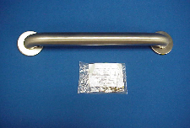
Part Number | Size A | Finish | Material
15012C | 12" | Bright Satin | Stainless Steel
15016C | 16" | Bright Satin | Stainless Steel
15018C | 18" | Bright Satin | Stainless Steel
15024C | 24" | Bright Satin | Stainless Steel
15030C | 30" | Bright Satin | Stainless Steel
15032C | 32" | Bright Satin | Stainless Steal
15036C | 36" | Bright Satin | Stainless Steel
15042C | 42" | Bright Satin | Stainless Steel
15048C | 48" | Bright Satin | Stainless Steel

Tel: (860) 263-3635, Fax: (860) 229-4328

E-mail: sales@csbint.biz

41 Hammer Hill Road,
Rocky Hill, CT 06067

