
Specification Sheet

C.S.B. INTERNATIONAL PRODUCTS INC.

1 ½" Low Inlet Bath Trap

Part Number | Size | Finish | Material
227LCP | 1 ½" 20GA | Chrome Plated | Brass
227LPC | 1 ½" 20GA | Polished Chrome | Brass
227LRB | 1 ½" 20GA | Rough Brass | Brass

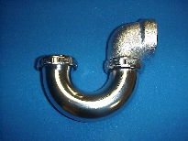

Tel: (860) 263-3635, Fax: (860) 229-4328

E-mail: sales@csbint.biz

41 Hammer Hill Road,
Rocky Hill, CT 06067

