
Specification Sheet

C.S.B. INTERNATIONAL PRODUCTS INC.

1 ½"x 7" Slip Joint Waste Arms W/Nut & Washer

Part Number | GA | Finish | Material
279CP | 22GA | Chrome Plated | Brass
279RB | 22GA | Rough Brass | Brass
3279CP | 20GA | Chrome Plated | Brass
3279RB | 20GA | Rough Brass | Brass
4279CP | 17GA | Chrome Plated | Brass
4279RB | 17GA | Rough Brass | Brass

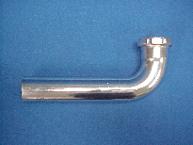

Tel: (860) 263-3635, Fax: (860) 229-4328

E-mail: sales@csbint.biz

41 Hammer Hill Road,
Rocky Hill, CT 06067

