
Specification Sheet

C.S.B. INTERNATIONAL PRODUCTS INC.
1 ½"x 24" Slip Joint Waste Arms W/Nut & Washer

Part Number | GA | Finish | Material
284CP | 22GA | Chrome Plated | Brass
284RB | 22GA | Rough Brass | Brass
3284CP | 20GA | Chrome Plated | Brass
3284RB | 20GA | Rough Brass | Brass
4284CP | 17GA | Chrome Plated | Brass
4284RB | 17GA | Rough Brass | Brass

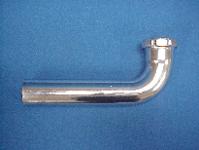

Tel: (860) 263-3635, Fax: (860) 229-4328

E-mail: sales@csbint.biz

41 Hammer Hill Road,
Rocky Hill, CT 06067

