
Specification Sheet

C.S.B. INTERNATIONAL PRODUCTS INC.

1 ¼" S-Trap Less Cleanout
Part Number | Size | Finish | Material
28-1CP | 1 ¼" 22GA. | Chrome Plated | Brass
28CP | 1 ¼" 20GA. | Chrome Plated | Brass
29CP | 1 ¼" 17GA. | Chrome Plated | Brass
*Note: 1. For Deep Flange add "D" to catalog number.
2. For Brass Nuts add "B" to catalog number.
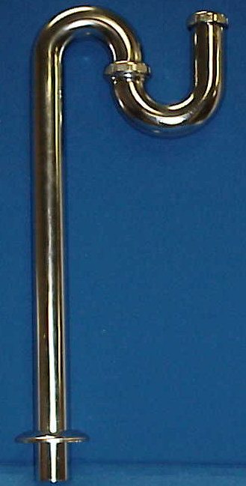

Tel: (860) 263-3635, Fax: (860) 229-4328

E-mail: sales@csbint.biz

41 Hammer Hill Road,
Rocky Hill, CT 06067

