
Specification Sheet

C.S.B. INTERNATIONAL PRODUCTS INC.

1 ¼" Repair Wall Bend

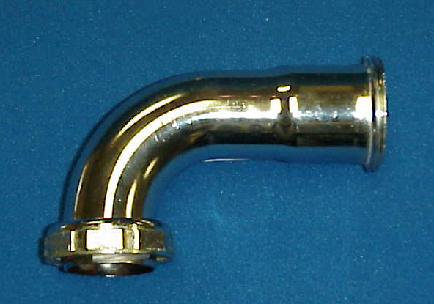
Part Number | Size | Finish | Material
30100RCP | 1 ¼" 20GA. | Chrome Plated | Brass

Tel: (860) 263-3635, Fax: (860) 229-4328

E-mail: sales@csbint.biz

41 Hammer Hill Road,
Rocky Hill, CT 06067

