
Specification Sheet

C.S.B. INTERNATIONAL PRODUCTS INC.

1 ½" Wall Bends

Part Number | Size | Finish | Material
30140-1CP | 1 ½" 22GA | Chrome Plated | Brass
30140CP | 1 ½" 20GA | Chrome Plated | Brass
30150CP | 1 ½" 17GA | Chrome Plated | Brass

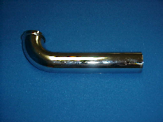

Tel: (860) 263-3635, Fax: (860) 229-4328

E-mail: sales@csbint.biz

41 Hammer Hill Road,
Rocky Hill, CT 06067

