Specification Sheet

The Connecticut Stamping & Bending Company

1 ½ " Repair Wall Bend

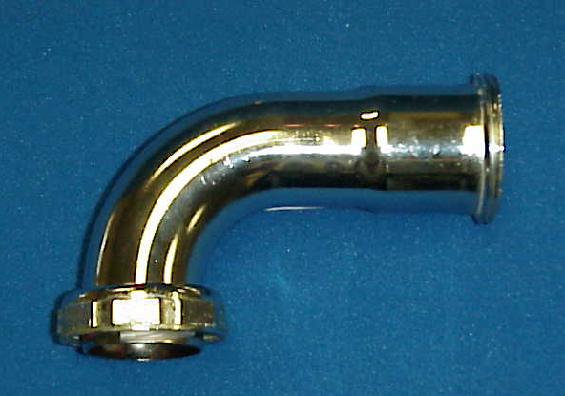
Part Number | Size | Finish | Material
30140RCP | 1 ½" 20GA. | Chrome Plated | Brass

Tel: (860) 225-4637, Fax: (860) 229-4328

Toll Free: 1-800-966-6964, E-mail: sales@macristy.com

206 Newington Avenue, P.O. Box 2380

New Britain, CT 06050

