
Specification Sheet

C.S.B. INTERNATIONAL PRODUCTS INC.

Continuous Waste Cast Tees w/Tailpieces
For End Outlet – Slip Joint

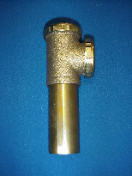
Part Number | Size | Finish | Material
303CP | 1 ½" | Chrome Plated | Brass
303RB | 1 ½" | Rough Brass | Brass

Tel: (860) 263-3635, Fax: (860) 229-4328

E-mail: sales@csbint.biz

41 Hammer Hill Road,
Rocky Hill, CT 06067

