
Specification Sheet

C.S.B. INTERNATIONAL PRODUCTS INC.

1 ½" Disposer Kit

Part Number | Size | Finish | Material
303DK13CP | 1 ½"x13" 20GA. | Chrome Plated | Brass
303DK13RB | 1 ½"x13" 20GA. | Rough Brass | Brass
4303DK13CP | 1 ½"x13" 17GA. | Chrome Plated | Brass
4303DK13RB | 1 ½"x13" 17GA. | Rough Brass | Brass

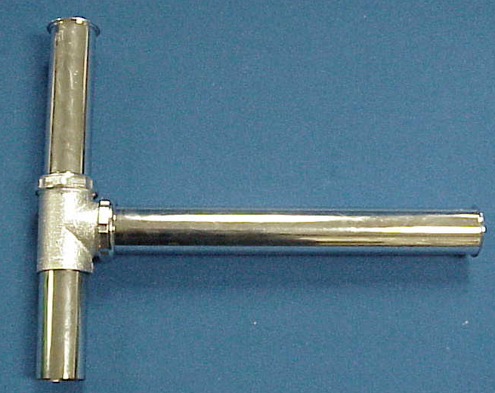

Tel: (860) 263-3635, Fax: (860) 229-4328

E-mail: sales@csbint.biz

41 Hammer Hill Road,
Rocky Hill, CT 06067

