
Specification Sheet

C.S.B. INTERNATIONAL PRODUCTS INC.

Hi-Way Inserts

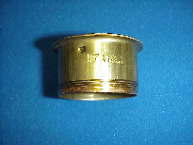
Part Number | Size | Finish | Material
304H3CP | 1 ½" 17GA | Chrome Plated | Brass
304H3RB | 1 ½" 17GA | Rough Brass | Brass

Tel: (860) 263-3635, Fax: (860) 229-4328

E-mail: sales@csbint.biz

41 Hammer Hill Road,
Rocky Hill, CT 06067

