
Specification Sheet

C.S.B. INTERNATIONAL PRODUCTS INC.

1 3/8" or 1 ½" Brass Chain & Stopper Style Drain
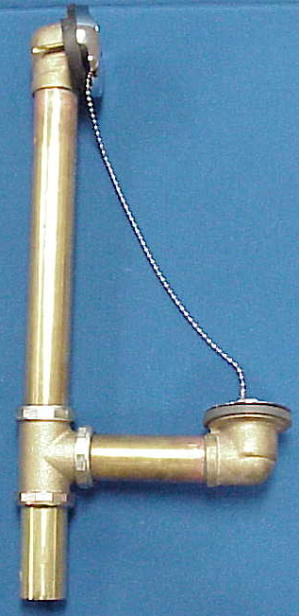

Part Number | Size | Finish | Material
308RB | 22GA. | Rough Brass | Brass
308CP | 22GA. | Chrome Plated | Brass
310RB | 17GA. | Rough Brass | Brass
310CP | 17GA. | Chrome Plated | Brass

Tel: (860) 263-3635, Fax: (860) 229-4328

E-mail: sales@csbint.biz

41 Hammer Hill Road,
Rocky Hill, CT 06067

