
Specification Sheet

C.S.B. INTERNATIONAL PRODUCTS INC.

LA Code Continuous Wastes w/Brass Nuts & Baffle Tee

Part Number | Size | Finish | Material
3265BDCP | 1 ½" x 16" | Chrome Plated | Brass
3265BDRB | 1 ½" x 16" | Rough Brass | Brass

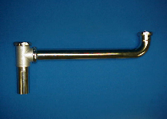

Tel: (860) 263-3635, Fax: (860) 229-4328

E-mail: sales@csbint.biz

41 Hammer Hill Road,
Rocky Hill, CT 06067

