
Specification Sheet

C.S.B. INTERNATIONAL PRODUCTS INC.

1 ½" OD Extra Heavy Castings w/Triplever Device,
1 5/8" Stamped Brass Strainer w/11 ½ T.P.I. Dome Grid w/Screw

Part Number | Size | Finish | Material
340CP | 20GA | Chrome Plated |  | Brass
340PB | 20GA | Polished Brass |  | Brass
340PVD | 20GA | Physical Vapor Deposition |  | Brass
342CP | 17GA | Chrome Plated |  | Brass
342PB | 17GA | Polished Brass |  | Brass
342PVD | 17GA | Physical Vapor Deposition |  | Brass

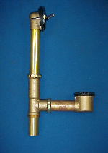

Tel: (860) 263-3635, Fax: (860) 229-4328

E-mail: sales@csbint.biz

41 Hammer Hill Road,
Rocky Hill, CT 06067

