
Specification Sheet

C.S.B. INTERNATIONAL PRODUCTS INC.

1 ½" O.D. Extra Heavy Castings
w/ 1 7/8" Lift & Turn Device w/ 11 ½ T.P.I.

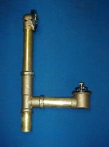

Tel: (860) 263-3635, Fax: (860) 229-4328

E-mail: sales@csbint.biz

41 Hammer Hill Road,
Rocky Hill, CT 06067

Part Number | Size | Finish | Material
340LCP | 20GA | Chrome Plated | Brass
340LPB | 20GA | Polished Brass | Brass
340LPVD | 20GA | Physical Vapor Deposition | Brass
342LCP | 17GA | Chrome Plated | Brass
342LPB | 17GA | Polished Brass | Brass
342LPVD | 17GA | Physical Vapor Deposition | Brass

