
Specification Sheet

C.S.B. INTERNATIONAL PRODUCTS INC.
1 ½" O.D. Extra Heavy Castings Side Outlet Tee
w/ 1 7/8" Lift & Turn Device w/11 ½ T.P.I

Part Number | Size | Finish | Material
340LSCP | 20GA | Chrome Plated | Brass
340LSPB | 20GA | Polished Brass | Brass
340LSPVD | 20GA | Physical Vapor Deposition | Brass

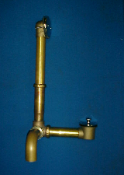

Tel: (860) 263-3635, Fax: (860) 229-4328

E-mail: sales@csbint.biz

41 Hammer Hill Road,
Rocky Hill, CT 06067

