
Specification Sheet

C.S.B. INTERNATIONAL PRODUCTS INC.

1 7/8"O.D. Touch & Stop Strainer

Part Number | Size | Finish | Material
343TCP | 1 7/8" O.D. x 11 ½" TPI | Chrome Plated | Brass
343TPB | 1 7/8" O.D. x 11 ½" TPI | Polished Brass | Brass
343TPVD | 1 7/8" O.D. x 11 ½" TPI | Physical Vapor Deposition | Brass

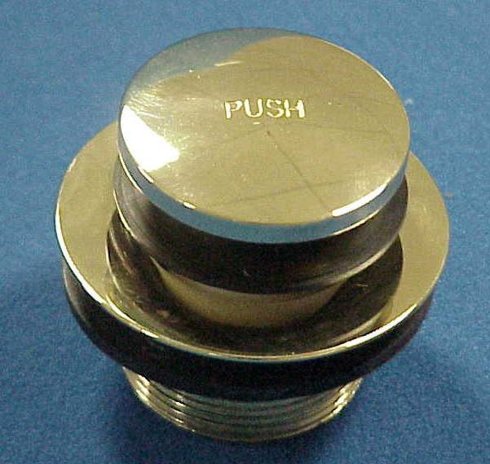

Tel: (860) 263-3635, Fax: (860) 229-4328

E-mail: sales@csbint.biz

41 Hammer Hill Road,
Rocky Hill, CT 06067

