
Specification Sheet

C.S.B. INTERNATIONAL PRODUCTS INC.

1 ½" S-Trap Less Cleanout
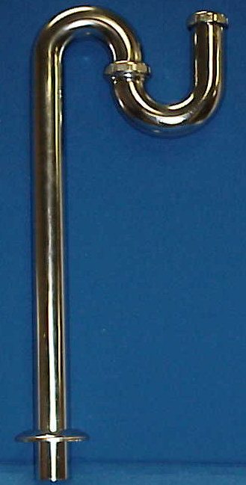
Part Number | Size | Finish | Material
36-1CP | 1 ½" 22GA. | Chrome Plated | Brass
36CP | 1 ½" 20GA. | Chrome Plated | Brass
37CP | 1 ½" 17GA. | Chrome Plated | Brass
*Note: 1. For Deep Flange add "D" to catalog number.
2. For Brass Nuts add "B" to catalog number

el: (860) 263-3635, Fax: (860) 229-4328

E-mail: sales@csbint.biz

41 Hammer Hill Road,
Rocky Hill, CT 06067

