
Specification Sheet

C.S.B. INTERNATIONAL PRODUCTS INC.

2" Sink Tailpieces

Part Number | Dim "A" | Finish | Material
3816-6CP | 6" | Chrome Plated | Brass
3816-8CP | 8" | Chrome Plated | Brass

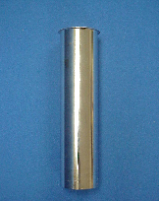

Tel: (860) 263-3635, Fax: (860) 229-4328

E-mail: sales@csbint.biz

41 Hammer Hill Road,
Rocky Hill, CT 06067

