
Specification Sheet

C.S.B. INTERNATIONAL PRODUCTS INC.

2" O.D. Closet Tank Elbows

Part Number | A x B | Finish | Material
427NCP | 4 x 6" 20GA | Chrome Plated | Brass
429NCP | 5 x 7" 20GA | Chrome Plated | Brass
431NCP | 6 x 8" 20GA | Chrome Plated | Brass
434NCP | 8 x 10" 20GA | Chrome Plated | Brass

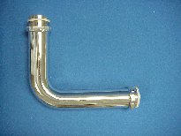

Tel: (860) 263-3635, Fax: (860) 229-4328

E-mail: sales@csbint.biz

41 Hammer Hill Road,
Rocky Hill, CT 06067

