
Specification Sheet

C.S.B. INTERNATIONAL PRODUCTS INC.

1 ½" x 6" x 8" Flushometer Elbow

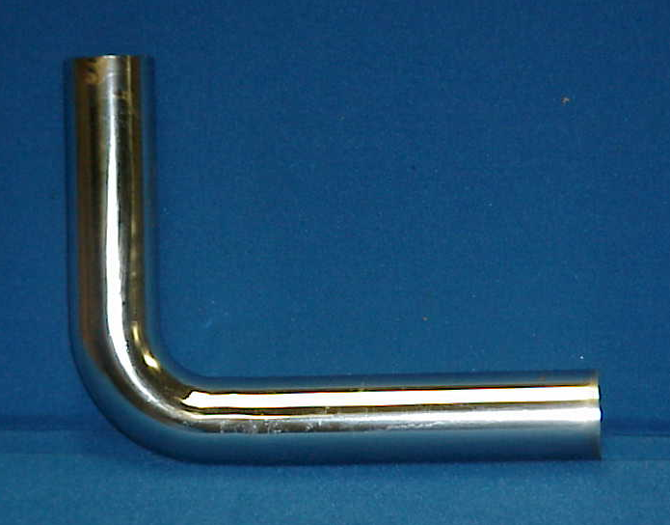
Part Number | Size | Finish | Material
440CP | 1 ½" x 6" x 8" 20GA. | Chrome Plated |  | Brass

Tel: (860) 263-3635, Fax: (860) 229-4328

E-mail: sales@csbint.biz

41 Hammer Hill Road,
Rocky Hill, CT 06067

