
Specification Sheet

C.S.B. INTERNATIONAL PRODUCTS INC.

1 ½" Adjustable IPS Conn. Sink Trap

Part Number | Size | Color | Material
51227 | 1 ½" | White | Poly-Pro
61227 | 1 ½" | Black | Poly-Pro

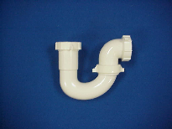

Tel: (860) 263-3635, Fax: (860) 229-4328

E-mail: sales@csbint.biz

41 Hammer Hill Road,
Rocky Hill, CT 06067

