
Specification Sheet

C.S.B. INTERNATIONAL PRODUCTS INC.

1 ½" Universal Continuous Wastes- End Outlet w/Baffle

Part Number | Size | Color | Material
51265 | 1 ½" x 16" | White | Poly-Pro
51265BAG | 1 ½" x 16" | White | Poly-Pro
61265 | 1 ½" x 16" | Black | Poly-Pro
61265BAG | 1 ½" x 16" | Black | Poly-Pro

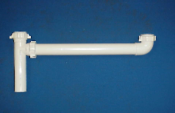

Tel: (860) 263-3635, Fax: (860) 229-4328

E-mail: sales@csbint.biz

41 Hammer Hill Road,
Rocky Hill, CT 06067

