
Specification Sheet

C.S.B. INTERNATIONAL PRODUCTS INC.

Universal Continuous Wastes- Telescopic End Outlet w/Branch Hose Connection

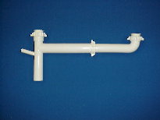
Part Number | Size | Color | Material
51265TEL1/2 | 1 ½" x 16" | White | Poly-Pro
51265TEL1/2BAG | 1 ½" x 16" | White | Poly-Pro

Tel: (860) 263-3635, Fax: (860) 229-4328

E-mail: sales@csbint.biz

41 Hammer Hill Road,
Rocky Hill, CT 06067

