
Specification Sheet

C.S.B. INTERNATIONAL PRODUCTS INC.

1 ½" P-Trap (3 Nut)

Part Number | Size | Finish | Material
514 | 1 ½" | ~ | Poly-Pro -White
614 | 1 ½" | ~ | Poly-Pro -Black

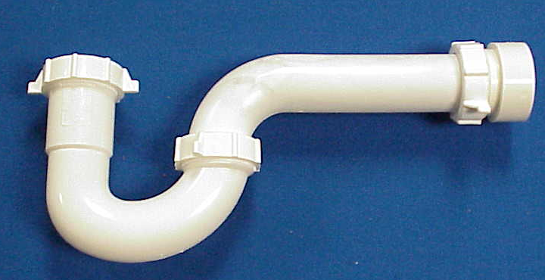

Tel: (860) 263-3635, Fax: (860) 229-4328

E-mail: sales@csbint.biz

41 Hammer Hill Road,
Rocky Hill, CT 06067

