
Specification Sheet

C.S.B. INTERNATIONAL PRODUCTS INC.

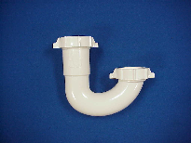1 ½" Repair J-Bends for P and S Traps

Part Number | Size | Color | Material
5140 | 1 ½" | White | Poly-Pro
5140BAG | 1 ½" | White | Poly-Pro
6140 | 1 ½" | Black | Poly-Pro
6140BAG | 1 ½" | Black | Poly-Pro

Tel: (860) 263-3635, Fax: (860) 229-4328

E-mail: sales@csbint.biz

41 Hammer Hill Road,
Rocky Hill, CT 06067

