
Specification Sheet

C.S.B. INTERNATIONAL PRODUCTS INC.

Ground Joint Waste Connections
1 ½ I.P.S. Male x 1 ½ Slip Joint

Part Number | Size | Finish | Material
523MRB | 1 ½" x 1 ½" | Rough Brass | Brass

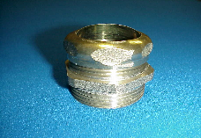

Tel: (860) 263-3635, Fax: (860) 229-4328

E-mail: sales@csbint.biz

41 Hammer Hill Road,
Rocky Hill, CT 06067

