
Specification Sheet

C.S.B. INTERNATIONAL PRODUCTS INC.

Ground Joint Waste Connections
1 ¼ I.P.S. Female x 1 ¼ Slip Joint

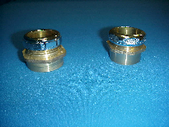
Part Number | Size | Finish | Material
524FRB | 1 ¼" | Rough Brass | Brass
528C | 1 ¼" | Polished Copper | Copper

524FRB & 528C

Tel: (860) 263-3635, Fax: (860) 229-4328

E-mail: sales@csbint.biz

41 Hammer Hill Road,
Rocky Hill, CT 06067

