
Specification Sheet

C.S.B. INTERNATIONAL PRODUCTS INC.

1 ½" Continuous Wastes End Outlet With Baffle, Slip Joint

Part Number | Size | Color | Material
5265 | 1 ½" x 16" | White | Poly-Pro
5265BAG | 1 ½" x 16" | White | Poly-Pro
6265 | 1 ½" x 16" | Black | Poly-Pro
6265BAG | 1 ½" x 16" | Black | Poly-Pro
5264 | 1 ½" x 21" | White | Poly-Pro
5264BAG | 1 ½" x 21" | White | Poly-Pro
6264 | 1 ½" x 21" | Black | Poly-Pro
6264BAG | 1 ½" x 21" | Black | Poly-Pro

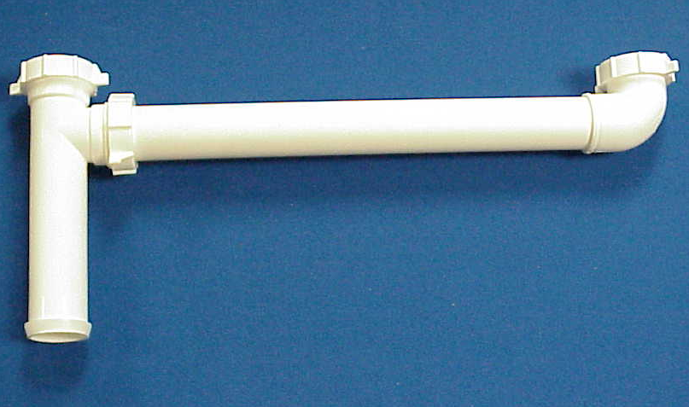

Tel: (860) 263-3635, Fax: (860) 229-4328

E-mail: sales@csbint.biz

41 Hammer Hill Road,
Rocky Hill, CT 06067

