
Specification Sheet

C.S.B. INTERNATIONAL PRODUCTS INC.

Continuous Waste 1 ½" End Outlet
ASTM F-409 PP UPC®

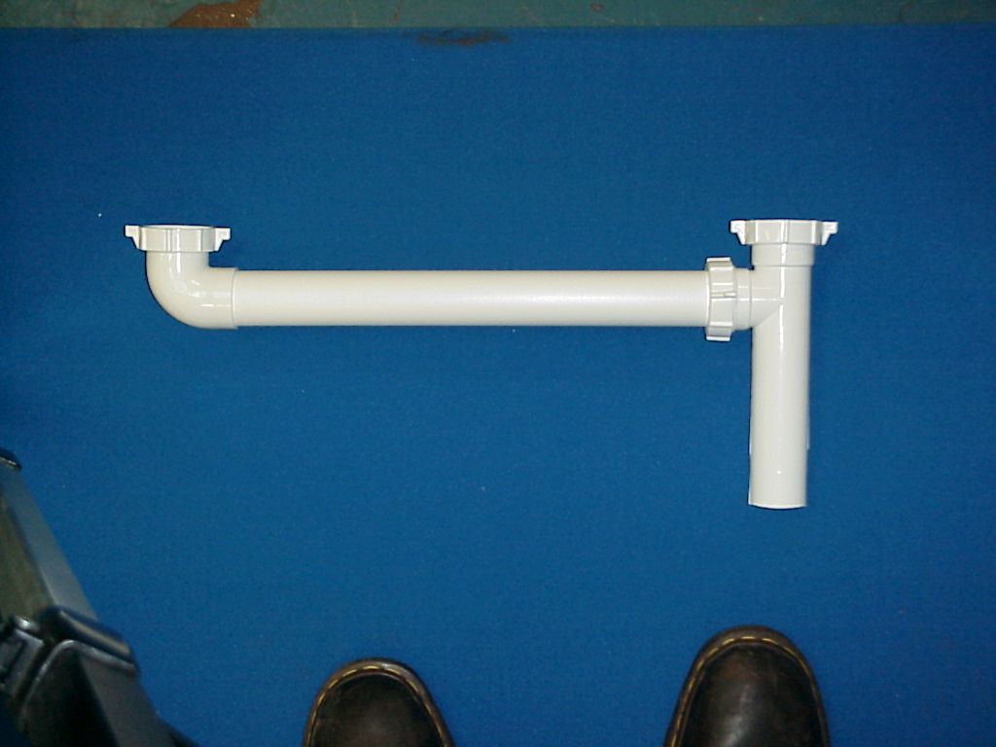
Part Number | Size | Color | Material
52650 | 1 ½" x 16" | White | Poly-Pro
52650BAG | 1 ½" x 16" | White | Poly-Pro
62650 | 1 ½" x 16" | Black | Poly-Pro
62650BAG | 1 ½" x 16" | Black | Poly-Pro
52640 | 1 ½" x 21" | White | Poly-Pro
52640BAG | 1 ½" x 21" | White | Poly-Pro
62640 | 1 ½" x 21" | Black | Poly-Pro
62640BAG | 1 ½" x 21" | Black | Poly-Pro

Tel: (860) 263-3635, Fax: (860) 229-4328

E-mail: sales@csbint.biz

41 Hammer Hill Road,
Rocky Hill, CT 06067

