
Specification Sheet

C.S.B. INTERNATIONAL PRODUCTS INC.

1 ½" Telescopic Slip Joint Continuous Wastes End Outlet W/Baffle

Part Number | Size | Color | Material
5265TEL | 1 ½ x 16" | White | Poly-Pro
5264TEL | 1 ½ x 21" | White | Poly-Pro

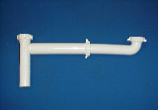

Tel: (860) 263-3635, Fax: (860) 229-4328

E-mail: sales@csbint.biz

41 Hammer Hill Road,
Rocky Hill, CT 06067

