
Specification Sheet

C.S.B. INTERNATIONAL PRODUCTS INC.

Continuous Wastes Direct Connect Center Outlet w/Baffle

Part Number | Size | Color | Material
52670 | 1 ½" x 16" | White | Poly-Pro
52680 | 1 ½" x 21" | White | Poly-Pro
62670 | 1 ½" x 16" | Black | Poly-Pro
62680 | 1 ½" x 21" | Black | Poly-Pro

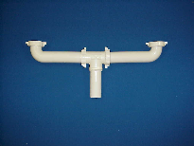

Tel: (860) 263-3635, Fax: (860) 229-4328

E-mail: sales@csbint.biz

41 Hammer Hill Road,
Rocky Hill, CT 06067

