
Specification Sheet

C.S.B. INTERNATIONAL PRODUCTS INC.

1 ½" Direct Connect Waste Arms

Part Number | Dim. "A" | Color | Material
52790 | 7" | White | Poly-Pro
62790 | 7" | Black | Poly-Pro
52800 | 9½" | White | Poly-Pro
62800 | 9½" | Black | Poly-Pro
52810 | 11½" | White | Poly-Pro
62810 | 11½" | Black | Poly-Pro
52820 | 15" | White | Poly-Pro
62820 | 15" | Black | Poly-Pro
52830 | 20" | White | Poly-Pro
62830 | 20" | Black | Poly-Pro
52840 | 24" | White | Poly-Pro
62840 | 24" | Black | Poly-Pro

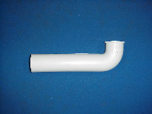

Tel: (860) 263-3635, Fax: (860) 229-4328

E-mail: sales@csbint.biz

41 Hammer Hill Road,
Rocky Hill, CT 06067

