
Specification Sheet

C.S.B. INTERNATIONAL PRODUCTS INC.

Ground Joint Waste Connections
1 ½ I.P.S. Female x 1 ½ Slip Joint

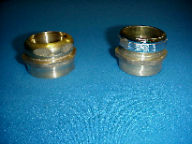
Part Number | Size | Finish | Material
527FRB | 1 ½ x 1 ½" | Rough Brass | Brass
530C | 1 ½ x 1 ½" | Polished Copper | Copper

527FRB & 530C

Tel: (860) 263-3635, Fax: (860) 229-4328

E-mail: sales@csbint.biz

41 Hammer Hill Road,
Rocky Hill, CT 06067

