
Specification Sheet

C.S.B. INTERNATIONAL PRODUCTS INC.

1 ½" O.D. Tube Size w/Triplever Device.
1 7/8 Strainer w/ 11 ½ T.P.I. Domed Grid & Screw

Part Number | Trim | Material
5340CP | Chrome Plated |  | Poly-Pro/ White
5340PB | Polished Brass |  | Poly-Pro/ White
5340PVD | Physical Vapor Deposition |  | Poly-Pro/ White
6340CP | Chrome Plated |  | Poly-Pro/ Black
6340PB | Polished Brass |  | Poly-Pro/ Black
6340PVD | Physical Vapor Deposition |  | Poly-Pro/ Black

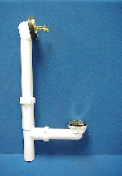

Tel: (860) 263-3635, Fax: (860) 229-4328

E-mail: sales@csbint.biz

41 Hammer Hill Road,
Rocky Hill, CT 06067

