
Specification Sheet

C.S.B. INTERNATIONAL PRODUCTS INC.
1 ½" Slip Joint Elbows

Part Number | OD x Dim "A" | Finish | Material
536-6CP | 1 ½" x 6" | Chrome Plated | Brass
536-8CP | 1 ½" x 8" | Chrome Plated | Brass
536-12CP | 1 ½" x 12" | Chrome Plated | Brass

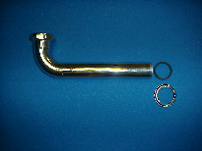

Tel: (860) 263-3635, Fax: (860) 229-4328

E-mail: sales@csbint.biz

41 Hammer Hill Road,
Rocky Hill, CT 06067

