
Specification Sheet

C.S.B. INTERNATIONAL PRODUCTS INC.

Slip Joint One End Extension Tubes w/Nut

Part Number | Dim "A" | Color | Material
58096 | 6" | White | Poly-Pro
68096 | 6" | Black | Poly-Pro
58098 | 8" | White | Poly-Pro
68098 | 8" | Black | Poly-Pro
58090 | 12" | White | Poly-Pro
68090 | 12" | Black | Poly-Pro

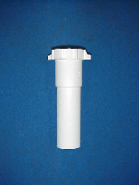

Tel: (860) 263-3635, Fax: (860) 229-4328

E-mail: sales@csbint.biz

41 Hammer Hill Road,
Rocky Hill, CT 06067

