
Specification Sheet

C.S.B. INTERNATIONAL PRODUCTS INC.

Sink Tailpieces, Flanged One End

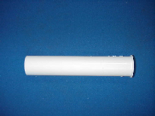
Part Number | Dim. "A" | Color | Material
58124 | 4" | White | Poly-Pro
68124 | 4" | Black | Poly-Pro
58126 | 6" | White | Poly-Pro
68126 | 6" | Black | Poly-Pro
58128 | 8" | White | Poly-Pro
68128 | 8" | Black | Poly-Pro
58120 | 12" | White | Poly-Pro
68120 | 12" | Black | Poly-Pro

Tel: (860) 263-3635, Fax: (860) 229-4328

E-mail: sales@csbint.biz

41 Hammer Hill Road,
Rocky Hill, CT 06067

