
Specification Sheet

C.S.B. INTERNATIONAL PRODUCTS INC.

Direct Connect Dishwasher Branch Tailpieces w/ ¾" Hose Clamp

Part Number | Size | Color | Material
58558 | 1 ½ x 8 ¾" | White | Poly-Pro
68558 | 1 ½ x 8 ¾" | Black | Poly-Pro

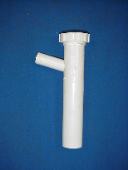

Tel: (860) 263-3635, Fax: (860) 229-4328

E-mail: sales@csbint.biz

41 Hammer Hill Road,
Rocky Hill, CT 06067

